**Informatics Institute of Technology**

BEng/BEng (Hons) Software Engineering

**4MMCS006C: Web Design and Development**

**Coursework**

**Individual Report**

Student group (IIT): Group A

Name: D.M.T.S.Dissanayake

IIT Student Number: 2016124

UOW Student Number: 16266405

**Content**

* Main body of report
* Workload
* Discussion
* Screen shots

How the pages developed comply with the Janet regulations of publishing pages on the Web

* accessibility;
* typography;
* colour (contrast / balance);
* Gestalt principles for grouping.
* Appendices
* Code
* Individual Statement
* Main body of report

**Workload**

Student role 3

* As I’m doing the tasks allocated to student role – 3, I created create a page with an interactive multiple choice quizzes. Once the quiz has been completed, it gives the user a mark on how he/she performed. This is time limited. When the quiz is finished it also displays the summary of the user performance (which answers were correct or incorrect, and how long it took to complete the quiz). The user will get 2 marks for each correct answer, and -1 for each wrong answer. The quiz consists of 10 questions. The background colour of the page changes according to the awarded mark.
* The second task was to add members’ details to the main page. I added photos of the members of the group. When the user moves the mouse over one photo, the details of that member displays in a separate area under the photo.
* We used a unique external style sheet used throughout the web site to display the same navigation, footer and header part.
* Added the CV.
* I added anchors to go to different sections.
* Then I added the title logo on the top and added a link to my CV in the bottom of the page.
* Finally I used additional JavaScripts to quiz page and main page to improve the interactivity.

**Discussion**

First I did a research about this and found some good ideas .After I got the basic idea I created a quiz with three questions. Then I found some good tutorials about making a countdown. With all these I created a basic quiz with a countdown.

With’ if- else’ statements I managed to redirect all answers to check whether those are correct or incorrect when the seconds of the countdown timer is zero

After that I improved the page little by little. I added a section to show the result and with css I managed to hide it until the user submits all answers. Then with the help of javascrip I managed to show the time used to complete the quiz.

While doing that a problem I faced was the countdown is starting on the moment I refresh the page. So to avoid that later a created two pages. One shows instructions about the quiz and all the quizzes are in the other page.

The second task was to add details of members. First I managed to add three photos of us. After going through various sources I learnt much more about mouse events .Then I created an external javascript to do the functional things.

However at the last moment I managed to complete all the tasks allocated to my role and I’m really happy about that.

**Screenshots**

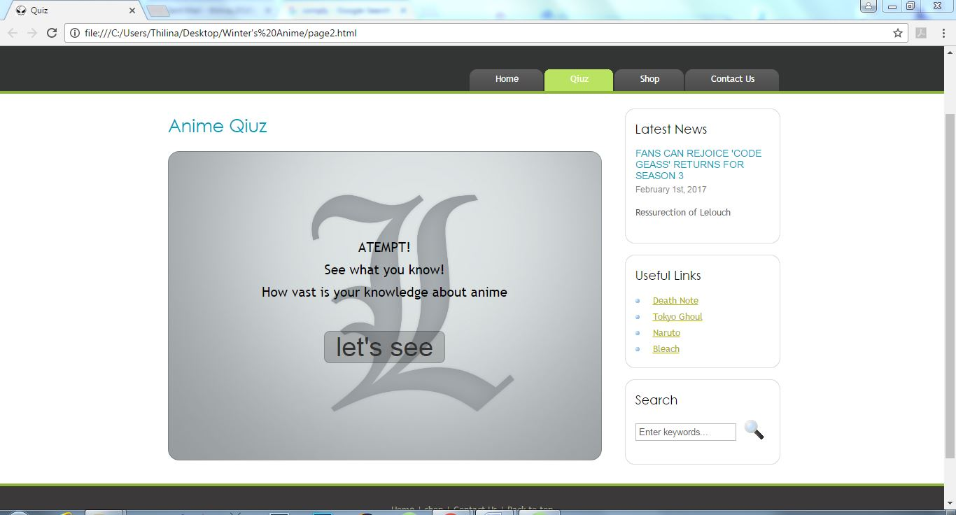

Page2.html

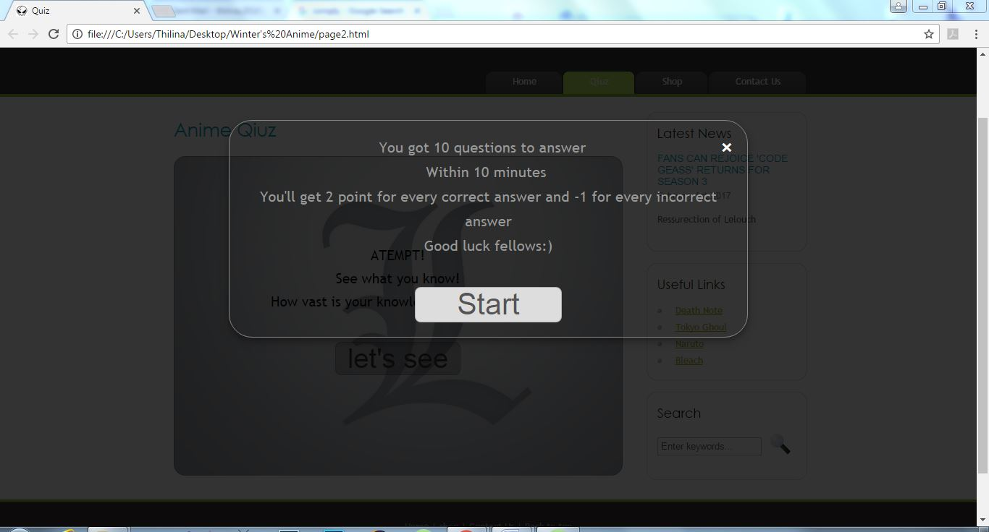

Page2.html

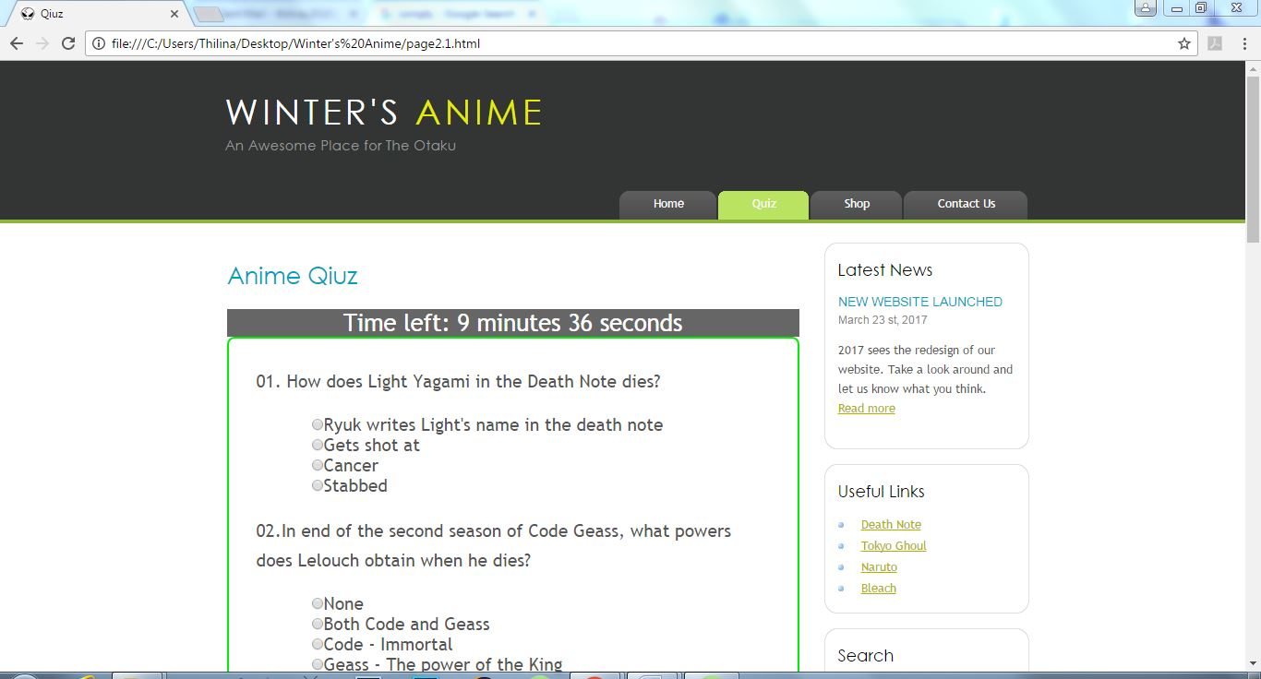

Page2.1.html

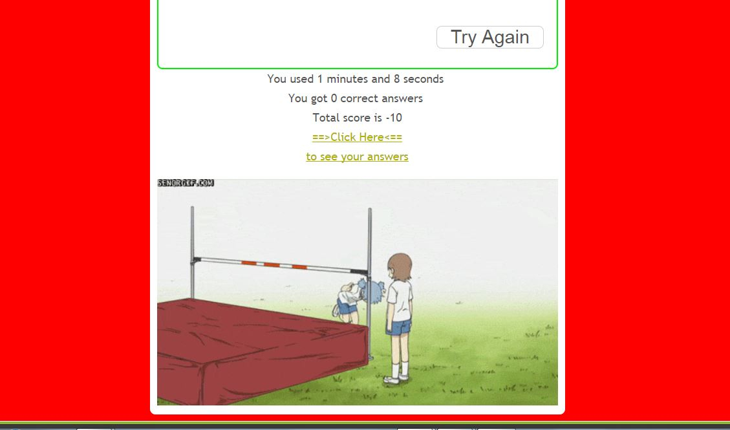

Page2.1.html

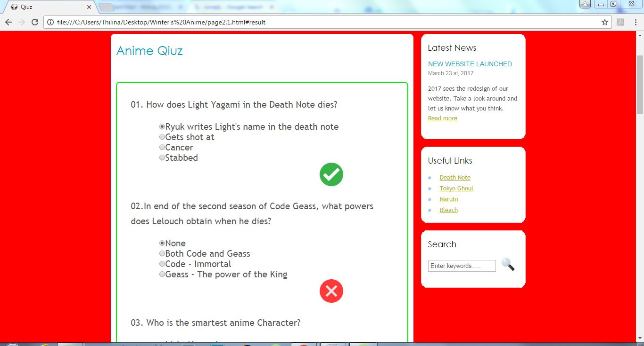

Page2.1.html

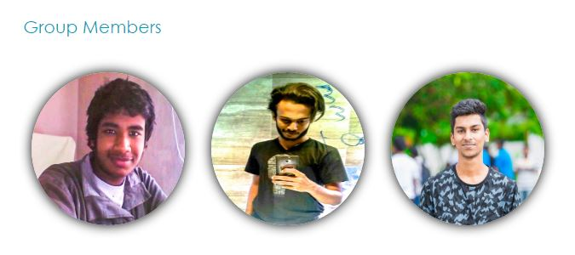

Main page(index.html)

**How the pages developed comply with the Janet regulations of publishing pages on the Web**

We are not using this website for any activity regarded as unlawful or potentially.

This doesn’t contain any offensive, obscene or indecent images, data or other material, or any data capable of being resolved into obscene or indecent images or material.

We did not publish any material with the intent to cause annoyance, inconvenience or needless anxiety.

This doesn’t contain material with the intent to defraud.

We did not publish any defamatory material.

We did not publish any material such that this infringes the copyright of another person.

This doesn’t deliberate unauthorized access to networked facilities or services.

Overall our site entirely complies with the Janet regulations of publishing pages on the web**.**

*https://community.jisc.ac.uk/library/acceptable-use-policy*

* **Accessibility –**
* To make the page more accessible, I used the <div> tags. I separated different parts and highlighted imported parts.
* **Typography –**

We added font styles in our unique external style sheet. (In few situations I changed only font sizes, color, and alignments using internal style sheet)

* For the body we used - Arial, sans-serif
* For h1, h2, h3 we used - 'century gothic', Arial
* For the title logo we used - 'century gothic', Arial, sans-serif
* For the footer we used - trebuchet ms', sans-serif

We didn’t want our viewers to distract with bright colors, so we used light colors for fonts.

We made sure each section gets a similar but different font style. This makes the website easier to read.

* **Color Contrast**

The header and footer have a grayish background while we have given the body a white background. The logo, which is in the header, is given a brightly color to make it easier to read with the dark background. In the quiz page, the quizzes are in a white background which makes viewers easy to concentrate on them. The timer is with a white font color in a dark background which separates quiz section and the timer.

Overall the color contrast in our website makes it easier to read and use.

* **Color Balance**

This is an entertaining site targeting for ‘otakus’. We used cool colors to give our user a sense of calm. We expect viewers to go through our site for hours and hours, so we added light and eye catching colors.

**Gestalt principles for grouping**

Similarity – for quizzes I separated them, added one style for quizzes and another for answers.

Order - for answers I ordered them vertically

Overall we provided a beautiful and stunning design in our website that follows the Gestalt principle.

* Appendices
* Code

**Quiz page one(page2.html)-html:**

<div id="content">

<h2 id="heading">Anime Qiuz</h2>

<div id="quiz_start"> <!—instruction part-->

<div id="quiz_start-content">

<p>ATEMPT!<br>See what you know!<br>How vast is your knowledge about anime<p>

<center><input type="button" id="button" value="let's see" onclick="start();" > </center>

</div>

</div>

<div id="myModal" class="modal">

<div class="modal-content">

<span class="close">&times;</span>

<p>You got 10 questions to answer<br>Within 10 minutes

<br>You'll get 2 point for every correct answer and -1 for every incorrect answer<br>Good luck fellows:)<p>

<center><input type="button" id="buttonStart" value="Start" onclick="location.href='page2.1.html'" > </center>

</div>

</div>

</div>

</div>

**Quiz page one(page2.html)-css:**

<style>

#heading{ font-size: 2em; width: 100%; text-align: left; }

#button{ width:30%; font-size: 2em; background-color: rgba(9, 9, 9, 0.2); border-radius: 8px; color: #333; border: 1px solid rgba(9,9,9,.2); cursor: pointer; }

#button:hover{ color: #111; }

#buttonStart{ width:30%; font-size: 2em; border-radius: 8px; color: #555; border: 1px solid rgba(9,9,9,.2); cursor: pointer; }

#buttonStart:hover{ color: #333; }

#quiz_start{ padding: 20px; height: 400px; border-radius: 16px; border: 1px solid rgba(9,9,9,.2); background-image: url("images/imageL.jpg"); background-size: cover; }

#quiz_start-content{ margin-top: 100px; font-size: 1.5em; color: #000; }

#content{ text-align: center; }

.modal { display: none; position: fixed; z-index: 1; padding-top: 100px; left: 0; top: 0; width: 100%; height: 100%; overflow: auto; background-color: rgb(0,0,0); background-color: rgba(0,0,0,0.8); }

.modal-content { position: relative; color: #999; font-size: 1.6em; margin: auto; border: 1px solid #888; border-radius: 32px; width: 50%; padding: 20px; box-shadow: 0 4px 8px 0 rgba(0,0,0,0.2),0 6px 20px 0 rgba(0,0,0,0.19); -webkit-animation-name: animatetop; -webkit-animation-duration: 0.4s;animation-name: animatetop; animation-duration: 0.4s }

@-webkit-keyframes animatetop { from {top:-300px; opacity:0} to {top:0; opacity:1} }

@keyframes animatetop { from {top:-300px; opacity:0} to {top:0; opacity:1} }

.close { color: white; float: right; font-size: 28px; font-weight: bold; }

.close:hover,.close:focus { color: #000; text-decoration: none; cursor: pointer; }

**Quiz page one(page2.html)-javascript:**

<script> var modal = document.getElementById('myModal'); // Get the modal

var span = document.getElementsByClassName("close")[0]; // Get the <span> element that closes the modal

function start() { modal.style.display = "block"; } // When the user clicks the button, open the modal

span.onclick = function() { modal.style.display = "none"; } </script> // When the user clicks on <span> (x), close the modal

**Quiz page one(page2.1.html)-html:**

<div id="content">

<h2 id="heading">Anime Qiuz</h2>

<div id = "quiz-time-left"></div><!—this is where countdown is-->

<form id="quiz" name="quiz" ><!—this is the quiz content-->

<div id="quiz-1">

<p>01. How does Light Yagami in the Death Note dies?</p>

<input type="radio" name="question01" value="ansCorrect">Ryuk writes Light's name in the death note<br>

<input type="radio" name="question01" value="anscorrect">Gets shot at<br>

<input type="radio" name="question01" value="anscorrect">Cancer<br>

<input type="radio" name="question01" value="anscorrect">Stabbed<br>

<div id = "infoSummary-01"></div>

</div><br>

<div id="quiz-2">

<p>02.In end of the second season of Code Geass, what powers does Lelouch obtain when he dies?</p>

<input type="radio" name="question02" value="anscorrect">None<br>

<input type="radio" name="question02" value="ansCorrect">Both Code and Geass<br>

<input type="radio" name="question02" value="anscorrect">Code - Immortal<br>

<input type="radio" name="question02" value="anscorrect">Geass - The power of the King<br>

<div id = "infoSummary-02"></div>

</div><br>

<div id="quiz-3">

<p>03. Who is the smartest anime Character?</p>

<input type="radio" name="question03" value="anscorrect">Light Yagami<br>

<input type="radio" name="question03" value="anscorrect">L. Lawliet<br>

<input type="radio" name="question03" value="ansCorrect">Lelouch vi Britannia<br>

<input type="radio" name="question03" value="anscorrect">Ceil Phantomive<br>

<div id = "infoSummary-03"></div>

</div><br>

<div id="quiz-4">

<p>04.How many code users are there in Code Geass?</p>

<input type="radio" name="question04" value="ansCorrect">2<br>

<input type="radio" name="question04" value="anscorrect">1<br>

<input type="radio" name="question04" value="anscorrect">4<br>

<input type="radio" name="question04" value="anscorrect">3<br>

<div id = "infoSummary-04"></div>

</div><br>

<div id="quiz-5">

<p>05. Which character says this all the time - "I am just one hell of a butler" </p>

<input type="radio" name="question05" value="anscorrect">Kira<br>

<input type="radio" name="question05" value="ansCorrect">Sebastian<br>

<input type="radio" name="question05" value="anscorrect">Afro<br>

<input type="radio" name="question05" value="anscorrect">Goku<br>

<div id = "infoSummary-05"></div>

</div><br>

<div id="quiz-6">

<p>06. Which of these powers is the most dangerous?</p>

<input type="radio" name="question06" value="anscorrect">Campione<br>

<input type="radio" name="question06" value="anscorrect">Vampirism<br>

<input type="radio" name="question06" value="ansCorrect">Geass<br>

<input type="radio" name="question06" value="anscorrect">Sharringan<br>

<div id = "infoSummary-06"></div>

</div><br>

<div id="quiz-7">

<p>07. Who is an immortal?</p>

<input type="radio" name="question07" value="ansCorrect"> C.C<br>

<input type="radio" name="question07" value="anscorrect">Kira<br>

<input type="radio" name="question07" value="anscorrect">Goku<br>

<input type="radio" name="question07" value="anscorrect">Alucard<br>

<div id = "infoSummary-07"></div>

</div><br>

<div id="quiz-8">

<p>08.What did Lelouch seek the most?</p>

<input type="radio" name="question08" value="anscorrect">The Past<br>

<input type="radio" name="question08" value="ansCorrect">The Future<br>

<input type="radio" name="question08" value="anscorrect">The Present<br>

<input type="radio" name="question08" value="anscorrect">Power<br>

<div id = "infoSummary-08"></div>

</div><br>

<div id="quiz-9">

<p>09.Who was Lelouch in love with?</p>

<input type="radio" name="question09" value="anscorrect">C.C<br>

<input type="radio" name="question09" value="anscorrect">Euphimia<br>

<input type="radio" name="question09" value="ansCorrect">Sherly<br>

<input type="radio" name="question09" value="anscorrect">Kallen<br>

<div id = "infoSummary-09"></div>

</div><br>

<div id="quiz-10">

<p>10.What was C.C's ultimate wish in life?</p>

<input type="radio" name="question10" value="anscorrect">love<br>

<input type="radio" name="question10" value="anscorrect">power<br>

<input type="radio" name="question10" value="ansCorrect">death<br>

<input type="radio" name="question10" value="anscorrect">food<br>

<div id = "infoSummary-10"></div>

</div><br>

<br>

<input type="button" id="button" value="Done" onclick="check()">

<input type="button" id="buttonReplay" value="Try Again" onclick="reload()">

</form>

<div id="afterSubmit">

<p id = "result"></p>

<img id = "picture">

</div>

</div>

</div>

**Quiz page one(page2.1.html)-css:**

<style> #content{ background-color: #fff;border-radius: 8px; border: 1px solid #fff; padding: 10px; }

#quiz{ font-size: 1.5em; visibility:visible; border: 2px solid #0e0; border-radius: 8px; padding: 30px; }

input{ margin-left: 60px; cursor: pointer; }

#heading{ font-size: 2em; width: 100%; }

#quiz-time-left{ font-size: 2em; text-align: center; width:100%; visibility:visible; color: #fff; background-color: rgba(0,0,0,.6); }

#afterSubmit{ visibility: hidden; width: 100%; }

#button{ width:25%; font-size: 1.5em; margin-left: 400px; visibility:visible; background-color: white; border-radius: 8px; color: #555; border: 1px solid rgba(9,9,9,.2); cursor: pointer; }

#buttonReplay{ width:30%; font-size: 1.5em; margin-left: 400px;visibility:hidden; background-color: white; border-radius: 8px; color: #555; border: 1px solid rgba(9,9,9,.2); cursor: pointer;}

#button:hover{ color: #333; }

#buttonReplay:hover{ color:#333; }

#picture{ width: 100%; margin: 0px; }

#result{ text-align: center; font-size: 1.4em; }

#infoSummary-01, #infoSummary-02, #infoSummary-03, #infoSummary-04, #infoSummary-05,

#infoSummary-06, #infoSummary-07, #infoSummary-08, #infoSummary-09, #infoSummary-10{ visibility:hidden; margin-left: 400px; } </style>

**Quiz page one(quiz.js)-javascript:**

/*countdown*/

var total_seconds =60*10;

var c_minutes = parseInt(total_seconds/60);

var c_seconds = parseInt(total_seconds%60);

function CheckTime(){ document.getElementById("quiz-time-left").innerHTML = 'Time left: '+c_minutes+' minutes '+c_seconds+' seconds';

if (total_seconds<=0) { check(); } else { total_seconds = total_seconds-1; c_minutes = parseInt(total_seconds/60); c_seconds = parseInt(total_seconds%60); setTime(); }}

setTime();

function setTime(){ var setTime= setTimeout("CheckTime()",1000);}

function check() { clearTimeout(setTime); var usedSec = 600-total_seconds; var m= parseInt(usedSec/60); var s= parseInt(usedSec%60);

/*get values of the user’s answer*/

var question01 = document.quiz.question01.value;

var question02 = document.quiz.question02.value;

var question03 = document.quiz.question03.value;

var question04 = document.quiz.question04.value;

var question05 = document.quiz.question05.value;

var question06 = document.quiz.question06.value;

var question07 = document.quiz.question07.value;

var question08 = document.quiz.question08.value;

var question09 = document.quiz.question09.value;

var question10 = document.quiz.question10.value;

var correct = 0; var score = 0;

var que =[question01, question02 ,question03 ,question04 , question05,

question06, question07 ,question08 , question09 , question10];

for(i=0;i<10;i++){ if (que[i] == "ansCorrect"){ correct++; score = score +2; addCorrect(i); }else{ score = score -1; addIncorrect(i); } }

var colorB = ["red","green","blue"]; var picture = ["images/fail.gif","images/won1.gif","images/won3.gif"]; var range;

if(score <= 10){ range = 0; }

if(score>10 && score<20 ){ range = 1; }

if(score == 20){ range = 2; }

document.body.style.backgroundColor = colorB[range];

if (!(score ==20)){ document.getElementById('buttonReplay').style.visibility = "visible"; }

document.getElementById('afterSubmit').style.visibility = "visible";

document.getElementById('quiz-time-left').style.visibility = "hidden";

document.getElementById('button').style.visibility = "hidden";

document.getElementById('result').innerHTML = "You used "+m+" minutes and " +s+" seconds <br> You got "+correct+ " correct answers <br> Total score is " +score+"<br><a href='#content'>==>Click Here<==<br>to see your answers</a>";

document.getElementById('picture').src = picture[range]; window.location.hash='#result'; }

function reload(){ location.reload(); window.location.hash='#main'; }

var suminfo =["infoSummary-01","infoSummary-02","infoSummary-03","infoSummary-04","infoSummary-05",

"infoSummary-06","infoSummary-07","infoSummary-08","infoSummary-09","infoSummary-10"];

function addCorrect(i) {

document.getElementById(suminfo[i]).style.visibility = "visible";

document.getElementById(suminfo[i]).innerHTML="<img src='images/corrcet.png' style='width:50px;height:50px;'>"; }

function addIncorrect(i) { document.getElementById(suminfo[i]).style.visibility = "visible";

document.getElementById(suminfo[i]).innerHTML ="<img src='images/incorrect.png' style='width:50px;height:50px;'>"; }

**Main page(index.html)-html;**

<h2>Group Members</h2>

<center> <div id="memberImages">

<div id="box_1">

<img src="images/member01.jpg" id="image_1" alt="Lingha" width="180px" height="180px" onmouseover="high1()" onmouseout="law1()">

</div>

<div id="detailBox1"></div>

<div id="box_2">

<img src="images/member02.jpg" id="image_2" alt="Shanka" width="180px" height="180px" onmouseover="high2()" onmouseout="law2()">

</div>

<div id="detailBox2"></div>

<div id="box_3">

<img src="images/member03.jpg" id="image_3" alt="Thilina" width="180px" height="180px" onmouseover="high3()" onmouseout="law3()">

</div>

<div id="detailBox3"></div>

</div> </center>

**Main page(index.html)-css;**

<style> #memberImages{ column-count: 3; }

#image_1, #image_2, #image_3{ margin-top: 20px; margin-bottom: 20px; border-radius: 50%; box-shadow: 0px 0px 20px black; cursor: pointer; } </style>

**Main page(members.js)-javascript;**

//make the div visible

function high1(){ document.getElementById('detailBox1').style.visibility="visible"; document.getElementById('detailBox1').innerHTML="<p>Lingha Dharshan<br>Student Role-Student 1</p>"}

function high2(){ document.getElementById('detailBox2').style.visibility="visible"; document.getElementById('detailBox2').innerHTML="<p>Shanka Koththagoda<br>Student Role-Student 2</p>"}

function high3(){ document.getElementById('detailBox3').style.visibility="visible"; document.getElementById('detailBox3').innerHTML="<p>Thilina Dissanayake<br>Student Role-Student 3</p>

//hide the div

function law1() { document.getElementById('detailBox1').style.visibility="hidden";}

function law2() { document.getElementById('detailBox2').style.visibility="hidden";}

function law3() { document.getElementById('detailBox3').style.visibility="hidden";}

|  |  |  |  |
| --- | --- | --- | --- |
| **Student Name:** | **D.M.T.S.Dissaanayake** | **Student Id:** | **2016124** |
| **State what tasks you carried out in the project.** | | | |
| I did tasks allocated to student 3.I designed the quiz page and member details in the main page with members photos. | | | |
| **State what you enjoyed and did not enjoy about teamwork.** | | | |
| We can get a clear idea about each other. It’s easy to solve big challenges with a team. Completion of the project successfully was an amazing experience for all of us  The thing I don’t like is in some situations if more people agreed to do something, the entire team has to do it though I dislike it. | | | |
| **State what you learnt about teamwork.** | | | |
| When we work with a team we can listen others ideas and share our own ones. We can discuss and always select the most suitable way of completing the work. | | | |
| **State what skills you gained/learnt from undertaking the project.** | | | |
| I learned how to engage with others in a team to achieve a common goal. I learnt how to do a successful web page. I improved many skills in this HTML 5 JavaScript and CSS. | | | |
| **State any strengths about yourself that emerged whilst undertaking the project.** | | | |
| My researching skills were emerged during the project. I was not good at researching earlier and I was doing everything in the last moment but through this project I realized that starting the project early can make the result more successful. | | | |
| **State any weaknesses about yourself that emerged whilst undertaking the project.** | | | |
| I realized that I am weak at giving feedbacks .Therefore I should further improve it in the future. | | | |
| **State how you would do things better if you were to undertake the project again.** | | | |
| As a team we did our best to make the project successful but if we get any chance to do it again we would add much more interactivity and add creative designs to it. | | | |
| **Additional general or project specific comments:** | | | |
|  | | | |
| **Student Signature:** | **Thilina** | **Date:** | **20/03/2017** |